Lab No 11
Lab Title:
Intro to C++ Arrays.
Objective:
The main Objective of this lab is to learn about arrays in C++.
Task 1:
Write a program of Array initialization in C++.
TOOLS:
A) PC B) Code Blocks
PROCEDURE:
i. First we create new project in Code blocks, Console then named it.
iii. Write the program which is required for our task, then build it.
iv. Compile the program and run it.
CODING:- | 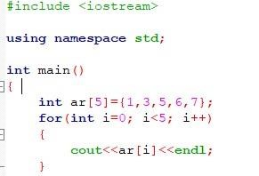
OUTPUT:- | 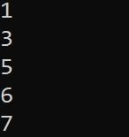
Task 2:
Write a program of Array declaration in C++.
PROCEDURE:
i. First we create new project in Code blocks, Console then named it.
iii. Write the program which is required for our task, then build it.
iv. Compile the program and run it.
CODING:- | 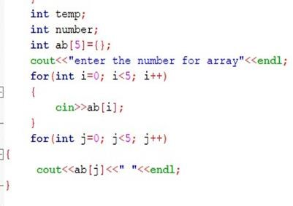
OUTPUT:- | 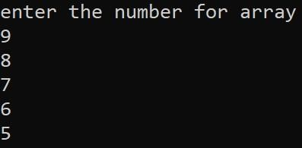
Task 3:
Write a program which Add all the elements of an array in C++.
PROCEDURE:
i. First we create new project in Code blocks, Console then named it.
iii. Write the program which is required for our task, then build it.
iv. Compile the program and run it.
CODING:- | 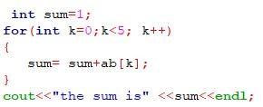
OUTPUT:- | 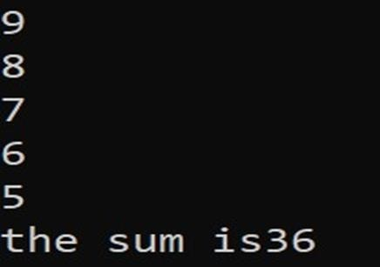
Task 4:
Write a program of Array sorting in C++.

PROCEDURE:
i. First we create new project in Code blocks, Console then named it.
iii. Write the program which is required for our task, then build it.
iv. Compile the program and run it.
CODING:- | 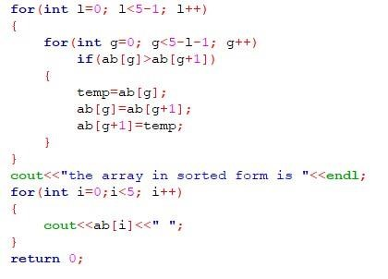
OUTPUT:- | 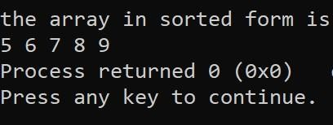
Conclusion:
We are familiar about how to use arrays in C++.

